Answers
1. There are four stages in the program development life cycle.
These are shown on the left of the table below. Match each of the tasks on the
right of the table to the stage which they occur. [4]
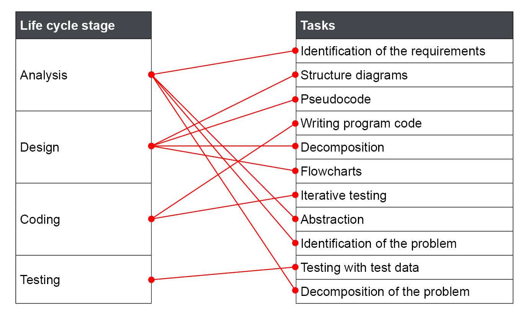
One mark for each stage that has all the correct connections.

2. (a) Explain what is meant by the term abstraction. [2]
Abstracting means removing the unnecessary detail from a problem (1) so that it is easier to focus on the parts that are relevant to a solution/the important parts (1).
(b) Satnav systems are used in cars to show a driver the streets that they are driving on.
Describe how abstraction is used by the designers of such devices when creating
their maps. [4]
They consider the important details (1) such as:
road length (1), junction points (1), road name (1), points of interest such as (1) schools/libraries/motorway services, speed limit of the road (1).
They ignore irrelevant details such as (1):
where trees are located, (1) whether crash barriers are present (1), the type of road surface (concrete or tarmac) (1).
Or any clear explanation/example of how abstraction has been used for these devices.

3. Pseudocode is often created to show how algorithms will work.
Describe two differences between pseudocode and a real programming language. [2]
Pseudocode cannot be compiled/run on a computer.
Pseudocode is easier to read than real programming code.
Pseudocode has easier syntax.
Pseudocode can be read by any competent programmer whereas programming code requires an understanding of the particular programming language.
Accept other appropriate differences between the two types of code.

[Total 12 marks]

